An
Expert Session
ON
Entrepreneurship Awareness Program (EAW)
ORGANIZED BY ED Cell
(SVMIT, BHARUCH)
Date: 3rd September, 2025
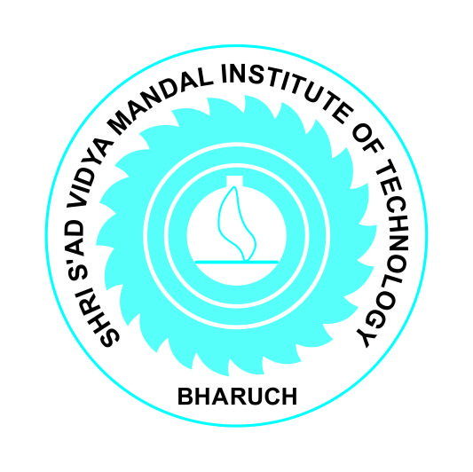
SHRI S’AD VIDYA MANDAL INSTITUTE OF TECHNOLOGY, BHARUCH - 392001

An Expert Session On
Entrepreneurship Awareness Program ORGANIZED BY ED Cell (SVMIT, BHARUCH)
Date: 3rd September,2025

Program Details
Detail | Description
Program Name | Entrepreneurship Awareness Program
Date | 3rd September 2025
Speaker | Avnish Hirpara
Coordinator | Prof. Jignasa Patel

During every quarter Ed Cell organizes various activities for the benefit of students and their development. In this last quarter, an expert talk on “Entrepreneurship Awareness Program” was conducted on 3rd September, 2025 for the SSIP students of Shri S’ad Vidya Mandal Institute of Technology The talk was delivered by Mr.Avnish Hirpara.
Total 144 students participated and were benefitted in gaining knowledge about how to start business and develop business mindset.

Executive Summary
The Entrepreneurship Awareness Program held on 3rd September 2025 was facilitated by esteemed speaker Avnish Hirpara and coordinated effectively by Prof. Jignasa Patel, under the aegis of the Centre for Entrepreneurship Development, Gujarat, a premier government organization dedicated to promoting entrepreneurship and skill development across the state since 1979. The session aimed to inspire and equip participants with foundational entrepreneurial knowledge, motivation, and awareness of available support mechanisms.

1. Background and Context
The Centre for Entrepreneurship Development (CED), Gujarat—established as an independent body in 1979—originated from a pioneering entrepreneurship training cell within GIIC during the early 1970s. It has grown to become the oldest organization of its kind in India, consistently spreading entrepreneurial training and skill development to diverse target groups across the state.
CED offers a variety of development programs, including the Entrepreneurship Awareness Program (EAP), focused on acquainting individuals with entrepreneurial concepts and pathways.

3. Highlights & Outcomes
• Motivation and Mindset: The session offered key insights into the entrepreneurial journey, emphasizing ideation, business planning, and resource navigation.
• Ecosystem Awareness: Participants learned about Gujarat’s thriving ecosystem for startups and the various schemes and support systems offered by CED and related institutions.
• Engagement and Inspiration: Through interactive discussions and real-world examples, the speaker encouraged attendees to explore entrepreneurial ventures with confidence.

4. Analysis and Discussion
While specific details such as attendee numbers or participant feedback are not publicly available, it's reasonable to infer that such programs typically:
- Serve as effective catalysts for igniting entrepreneurial curiosity.
- Provide clear orientation on next steps—like incubation, mentorship, and funding avenues.
- Help participants meaningfully engage with their entrepreneurial ambitions within a structured ecosystem.

5. Conclusion
The Entrepreneurship Awareness Program on 3rd September 2025—featuring Avnish Hirpara and orchestrated by Prof. Jignasa Patel under the aegis of CED Gujarat—played a vital role in fostering entrepreneurial awareness. By leveraging CED’s esteemed legacy and expertise, the program likely encouraged participants to explore startup prospects and engage with innovation-driven pathways.

6. Recommendations
• Post-event Documentation: Collate slides, summaries, attendee feedback, and photos to produce a detailed event report.
• Follow-Up Workshops: Organize hands-on sessions on ideation, business modeling, prototyping, and funding strategy.
• Mentorship Programs: Connect participants with industry professionals or successful entrepreneurs for guidance and support.
• Track Impact: Monitor participants’ progress to gauge program effectiveness through idea development or startup initiation.
• Visibility and Outreach: Share highlights, testimonials, and success stories on CED’s platforms to build momentum for future programs.

7. References
• Centre for Entrepreneurship Development, Gujarat—official site information (ced.gujarat.gov.in)
• Program-specific details provided: date, speaker, coordinator, and organizer.

Glimpse of Session
